**Data Science (Batch 03)**

**Name: Dilawar Ali**

**Group: 02**

**Task 1: An Introduction to Git.**

This will include installing Git and learning some basic commands: init, add, and commit, etc.

**Downloading Git:**

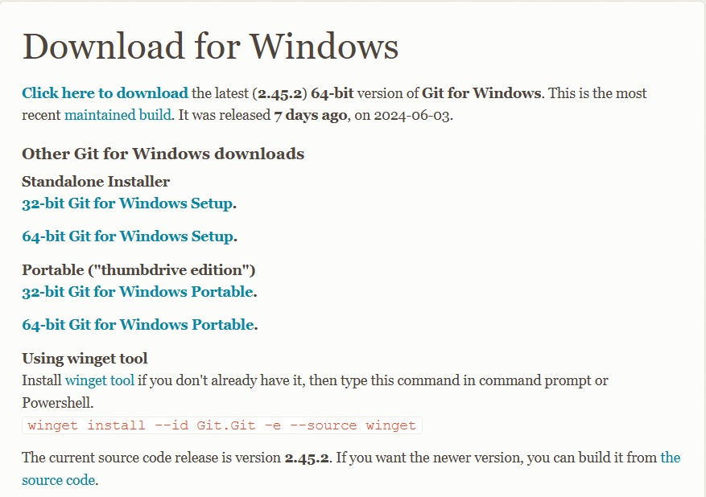

**Installing Git:**

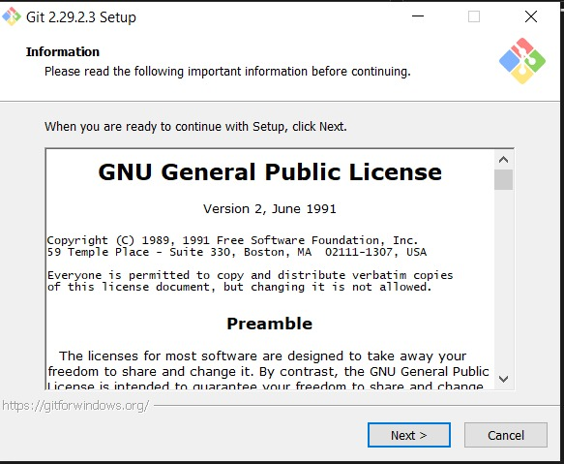

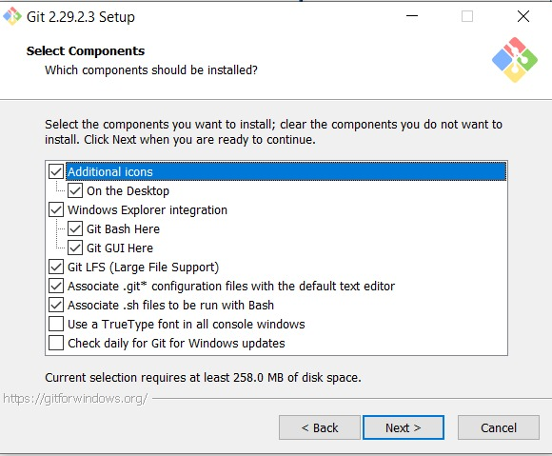



**Running Basic Commands:**

* **git init:** Initialize a new Git repository.



* **git add:** Add files to the staging area.



Before running the commit command, we must configure our username and email account.

* **Configure name and email:**

* **git commit:** Commit your changes to the repository.

* **git log & status:**

* **git branch:**

